Impact Stories
Impact Media Package
Impact Media Package

This document contains photos in JPEG format for your use during the United Way campaign.

Images can be copy and pasted into your campaign advertisements as well as used on social media.

Please contact United Way of KFL&A for any inquiries regarding the use or distribution of these images.

Local Agencies By The Numbers
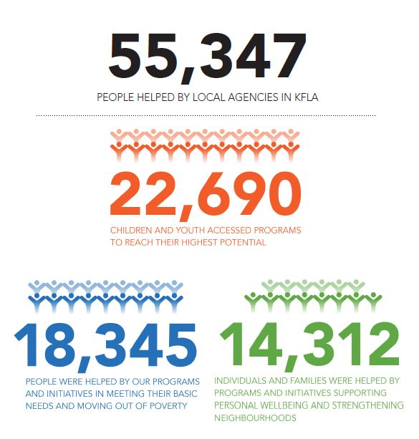
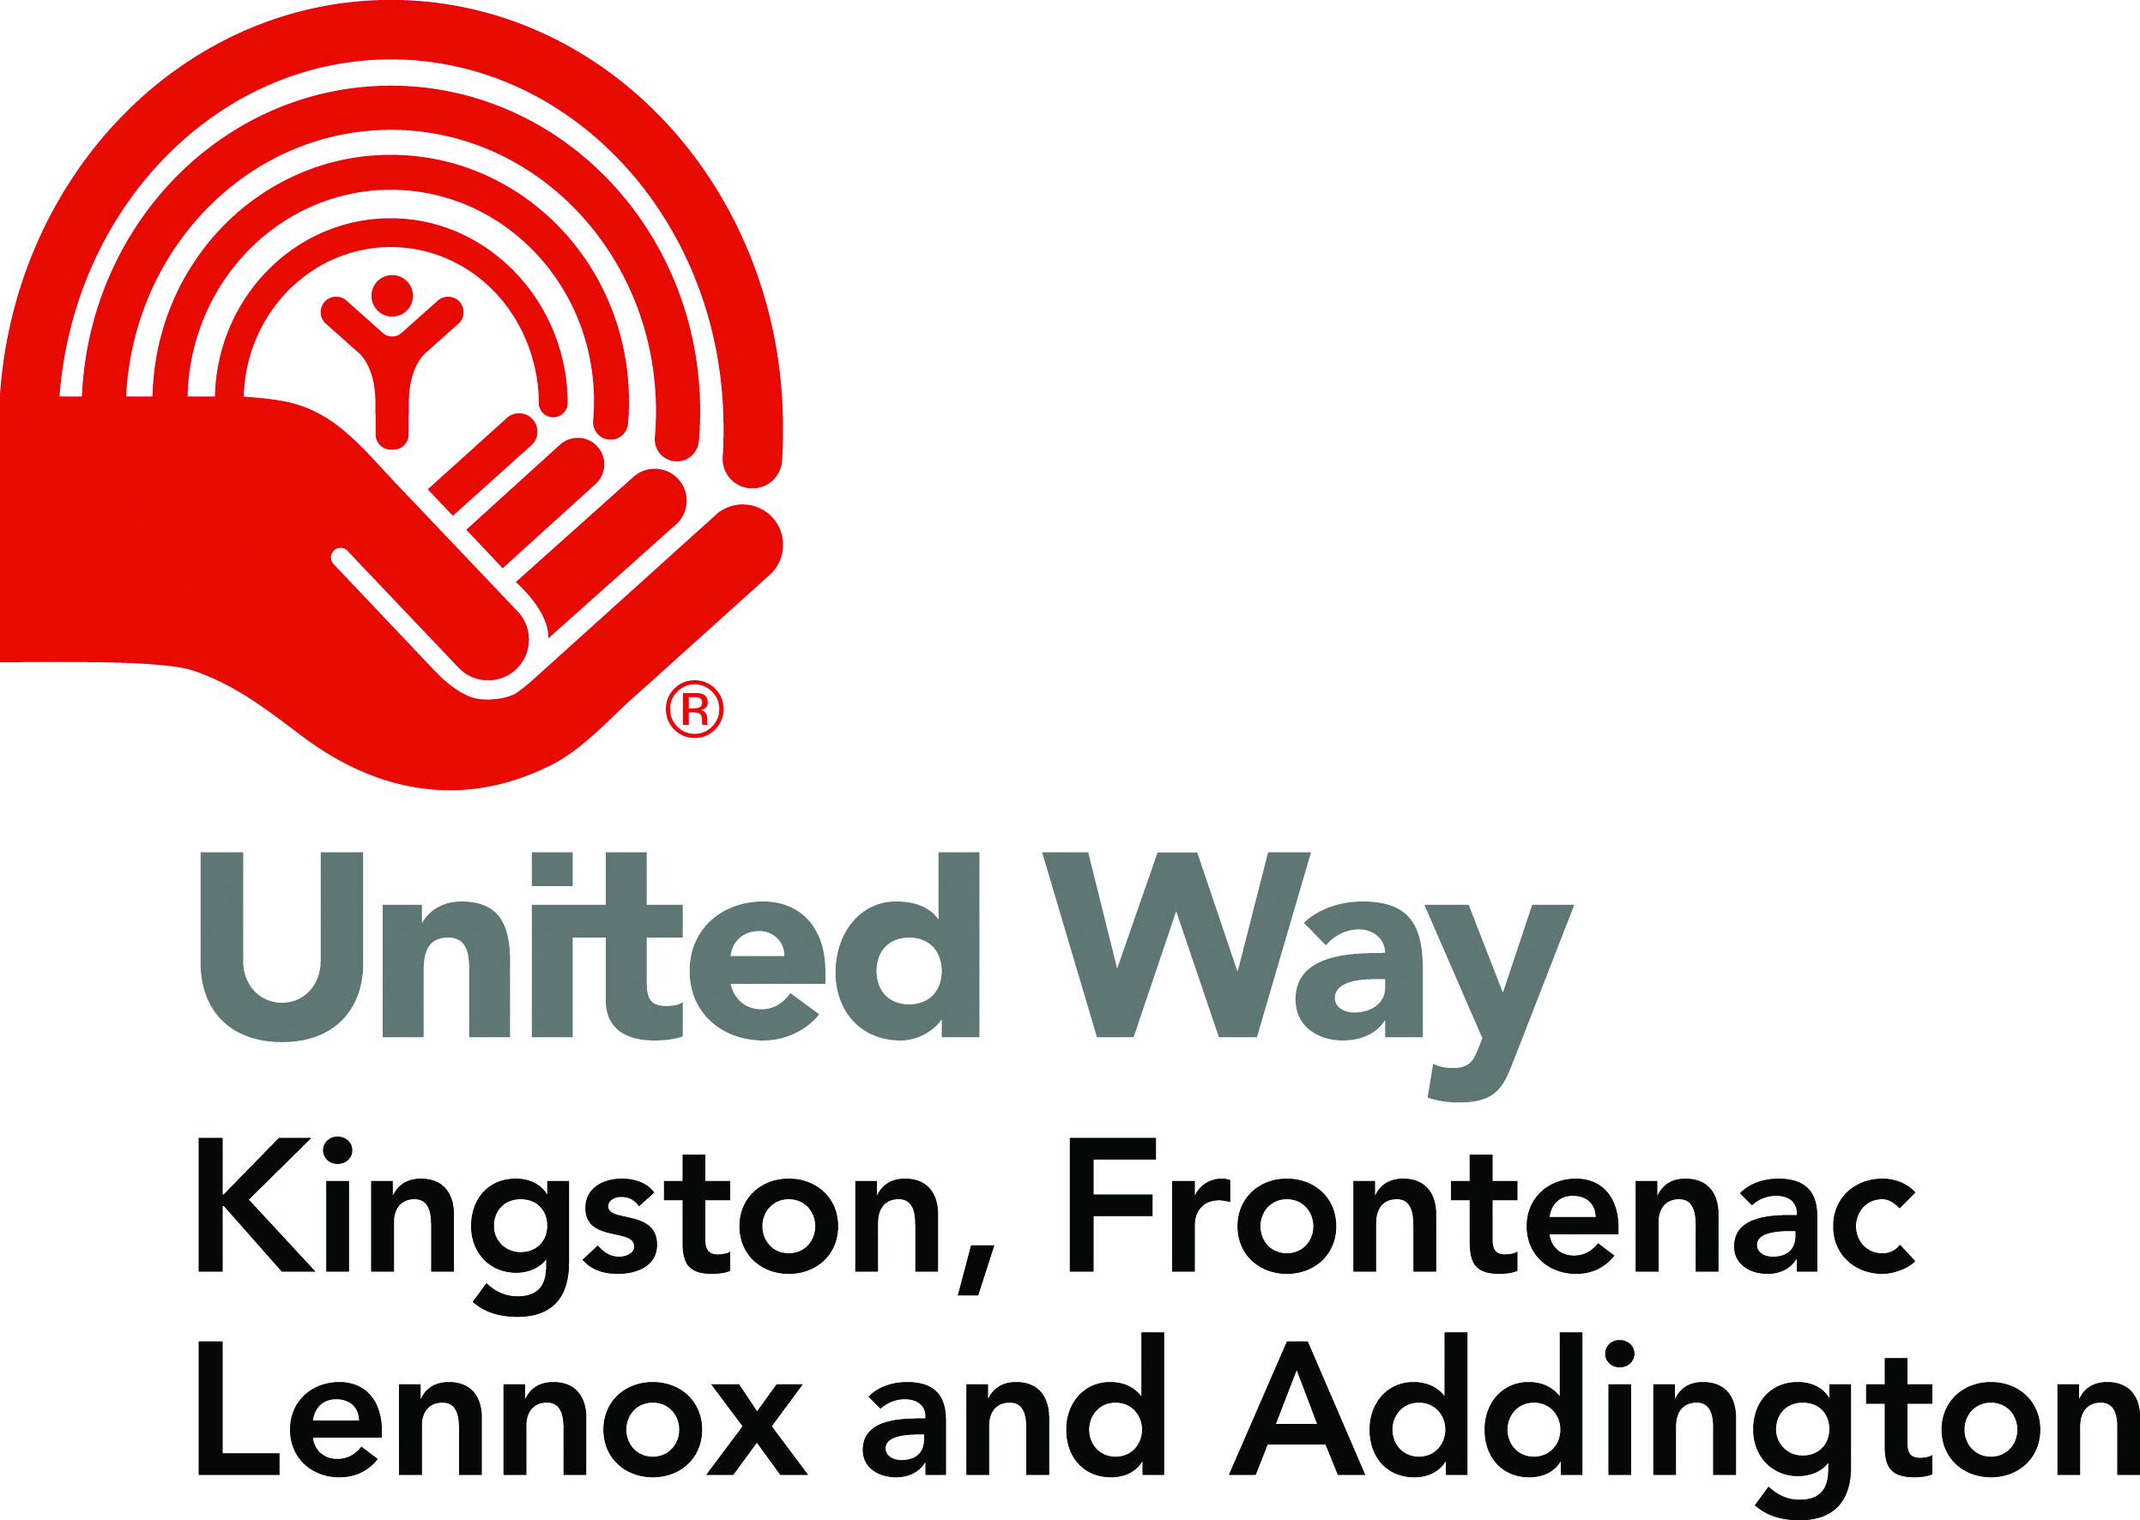
Impact Statments

United Way funding supports a network of agencies that provide vital programs to thousands of people in the region.
*Names are changed for privacy
Building Strong and Healthy Communities

- Erin and 1,800 others, accessed services by calling 211. She and 60% of callers live on low income and need help navigating services.
- Kamala uses a wheelchair and needed help to connect with support services, along with 2,600 others, to help her live independently.
- Debra lost her vision, and with 345 others like her, has learned daily living skills, including safe travel around the community.
- Dylan and 213 others improved their literacy skills through one-to-one tutoring and group sessions.
- Cory was one of 93 physically-disabled individuals who got help acquiring basic mobility devices.
- · 16-year-old Tammy lost her hearing and, along with 747 other Deaf or hard-of-hearing individuals, improved her coping skills through counselling and support.
- Paul, who has epilepsy, is one of 160 people who received support, information and services that helped him and his family
- Cynthia and 507 other women and their children left violent and abusive relationships by accessing safe, emergency shelter and supports.
- Cameron and 90 other rural residents in Frontenac County received free, confidential counselling in their own community.
- Stuart and 880 others learned better social, relationship and coping skills by accessing affordable professional counselling
- Ella, along with 80 other women coping with sexual violence issues, re-gained a sense of safety though supportive counselling.
- Janet was constantly in conflict with her parents and, along with 300 other children and youth, got help through youth and family counselling.
- Sheri and her 2 kids, like 37 other women and children, began rebuilding their lives free from physical abuse by moving into supportive transitional housing.
- After leaving the women’s emergency shelter, Maria, and 276 other women continued with skills training and supports through an outreach program in L&A County.
- Svetlana and 290 other seniors maintained an active, healthy lifestyle by participating in physical fitness and social activities at a location close to their homes.
- Jeremy, and 34 other individuals with a disability, received training and supports to eliminate barriers and became volunteers in their community.
- Yana, along with 1,300 residents of North Kingston, learned gardening skills and had access to affordable, locally grown produce at a farmers market in their own neighborhood.

Helping Kids Be All They Can Be
- 12 year-old Andrew is one of over 1,400 kids whose grades and behaviour improved thanks to a positive adult mentor.
- Erica, and 113 other youth living in North Frontenac, developed leadership skills through after-school programs in their rural community.
- Amina was struggling at school and is now on track to graduate, along with 279 other high school students from Rideau Heights and the Inner Harbour.
- Isaiah is 16 and was at risk of developing an alcohol addiction but through intervention and counselling, he and 322 other kids had help to overcome addictions.
- Francis often exhibited aggressive behavior. Along with 203 other youth, he learned new coping skills and a changed attitude.
- James, like 18 other youth marginalized by homelessness and mental health issues, got back on track with professional, practical help.
- With nutritious snacks and meals provided at school, Rochelle and 14,500 other students could focus on school work and learning, rather than their hunger.
- Emma was being bullied but, like 660 other girls aged 9 to 13, learned coping skills and acceptable behavior through in-school intervention workshops.
- Taylor and 38 LGBTQ youth gained confidence and belief in themselves through safe, positive peer support groups.
- Geoffrey and 24 other high school aged young men attended groups and received 1:1 counselling to learn about healthy relationships, conflict resolution, and consent.

Moving People From Poverty to Possibility
- Peter, along with125 other adults and youth, was homeless and was able to access emergency shelter, along with having their basic needs met.
- Kayla, one of 65 youth and adults who were previously homeless, learned to live
- independently through transitional housing.
- Amelia had a place to go and a hot meal every day, thanks to over 42,000 meals served each year by local soup kitchens.
- Julia is one of 4,000 of the most vulnerable people in our community who accessed free clothing and household items.
- Theresa, a young mom with two kids, struggling with managing on a low income, participated with other caregivers in prenatal, infant and parenting groups.
- Brianne’s 8 year old daughter, and 762 other children of low-income families, had warm boots for the winter.
- Kristy, and 1,000 other children from families struggling to make ends meet, started the school year with school supplies and backpacks.
- Amber and 262 other disadvantaged women received professional work clothes and received training and supports to help them find employment.
- Gary and 77 low-income adults found relief from pain through emergency dental services.
- Jocelyn got kicked out of her home. With 114 other youth, she found support and emergency shelter and returned to school.
- Grace is one of 170 high school students who learned the impact of poverty and the struggles faced daily by individuals with low incomes.
- Bruce and 473 other North Kingston residents on low income were provided with
- support and referrals to help them cope with daily living needs.
- Tanya, with a chronic mental health issue and problems with her landlord, accessed landlord–tenant mediation, and with 154 others received supports to maintain her tenancy.
- Brandon’s ID was stolen while living on the street. With 244 others, he was assisted with replacing identification documents and had access to personal voice mail to connect with potential landlords and employers.
- Aisha and 84 youth at risk of homelessness and struggling with issues like depression and anxiety remained housed with early intervention from a mobile mental health worker.
- 17 year old Natalie and 39 other youth in conflict with their parents accessed family mediation to resolve their differences.
- Hassan and 1,205 others at risk of eviction received support, advocacy, and legal aid remained housed
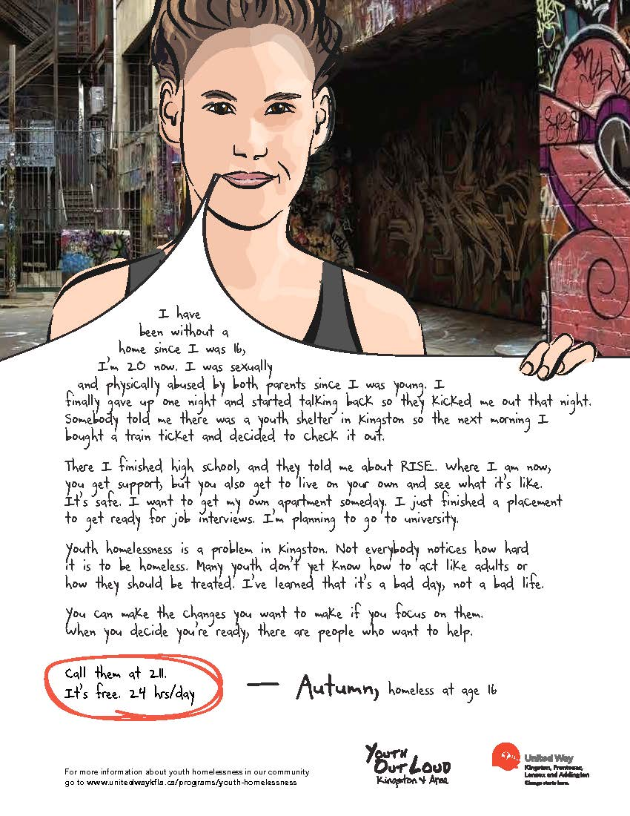
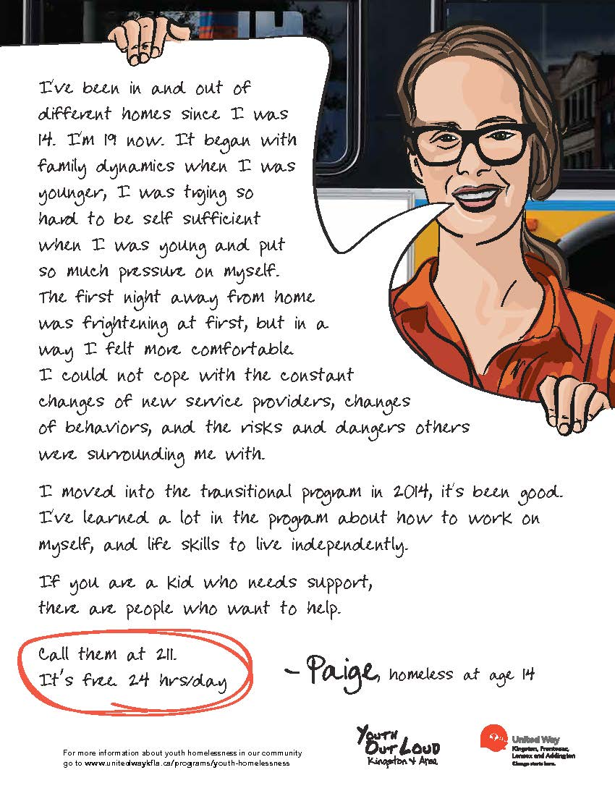
a
Youth Out Loud
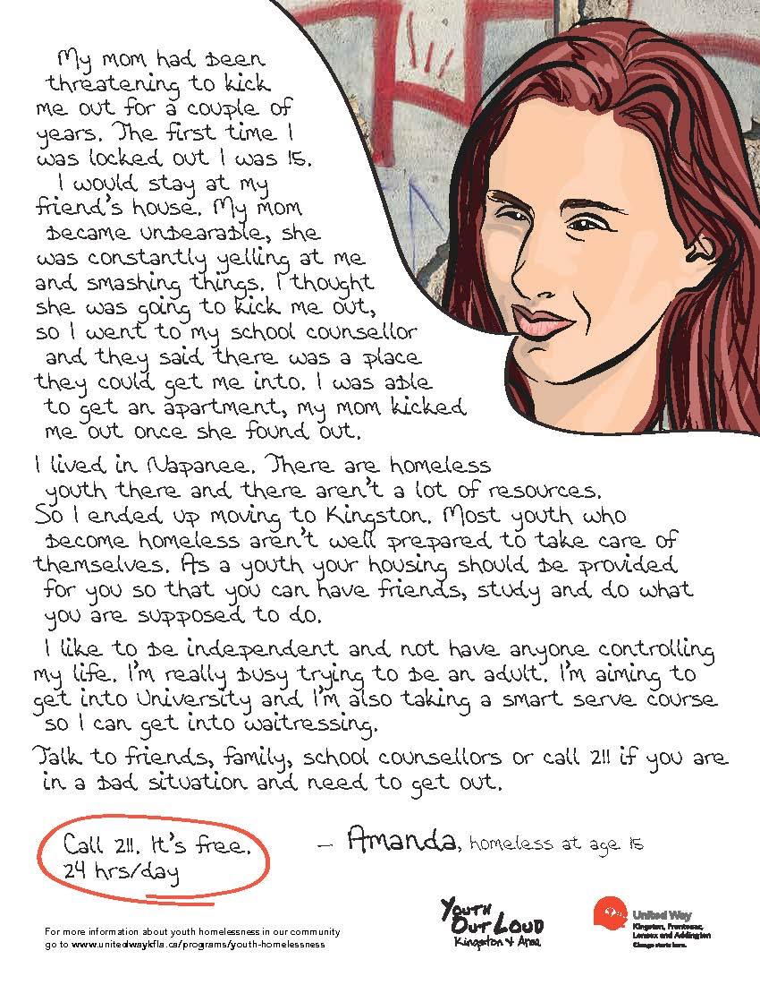
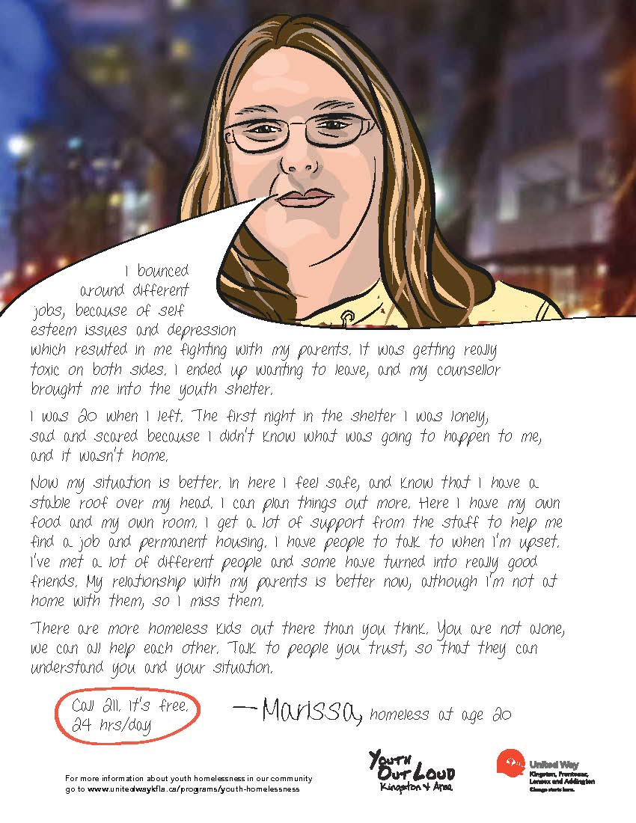

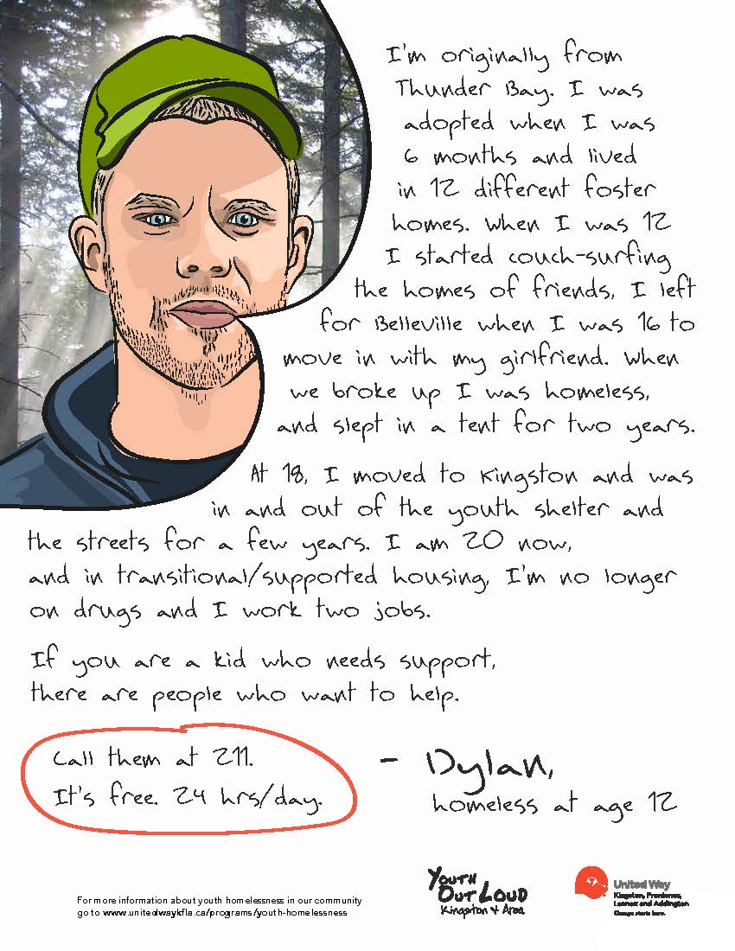
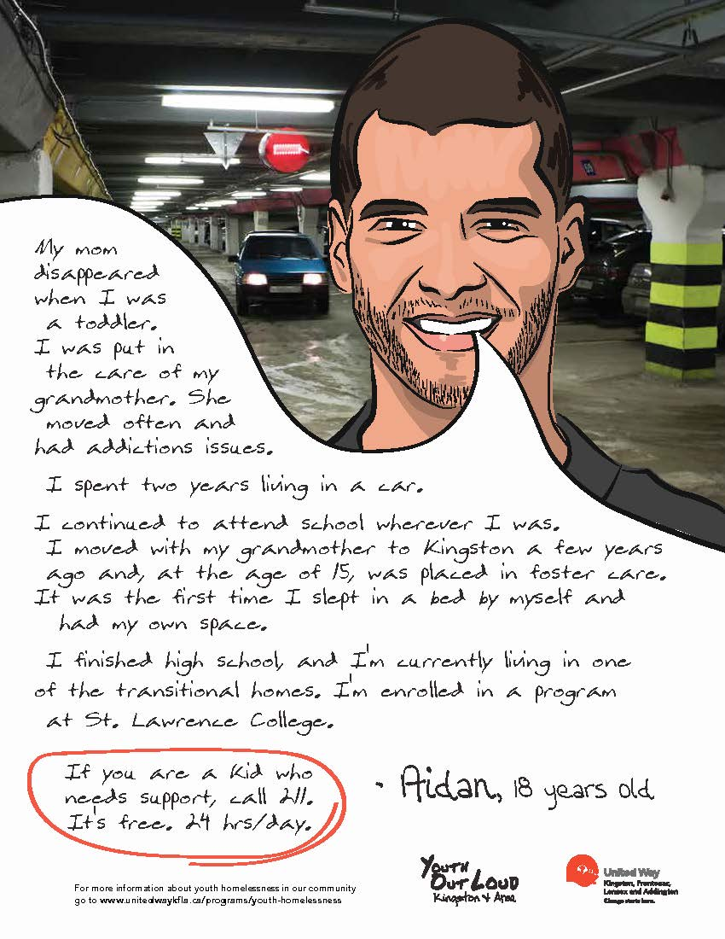

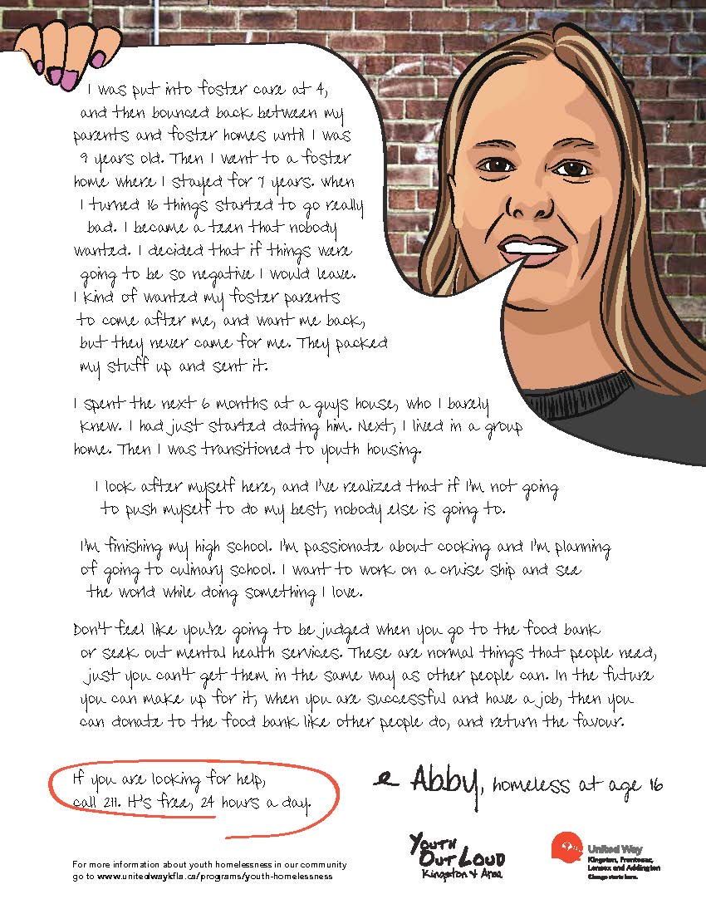

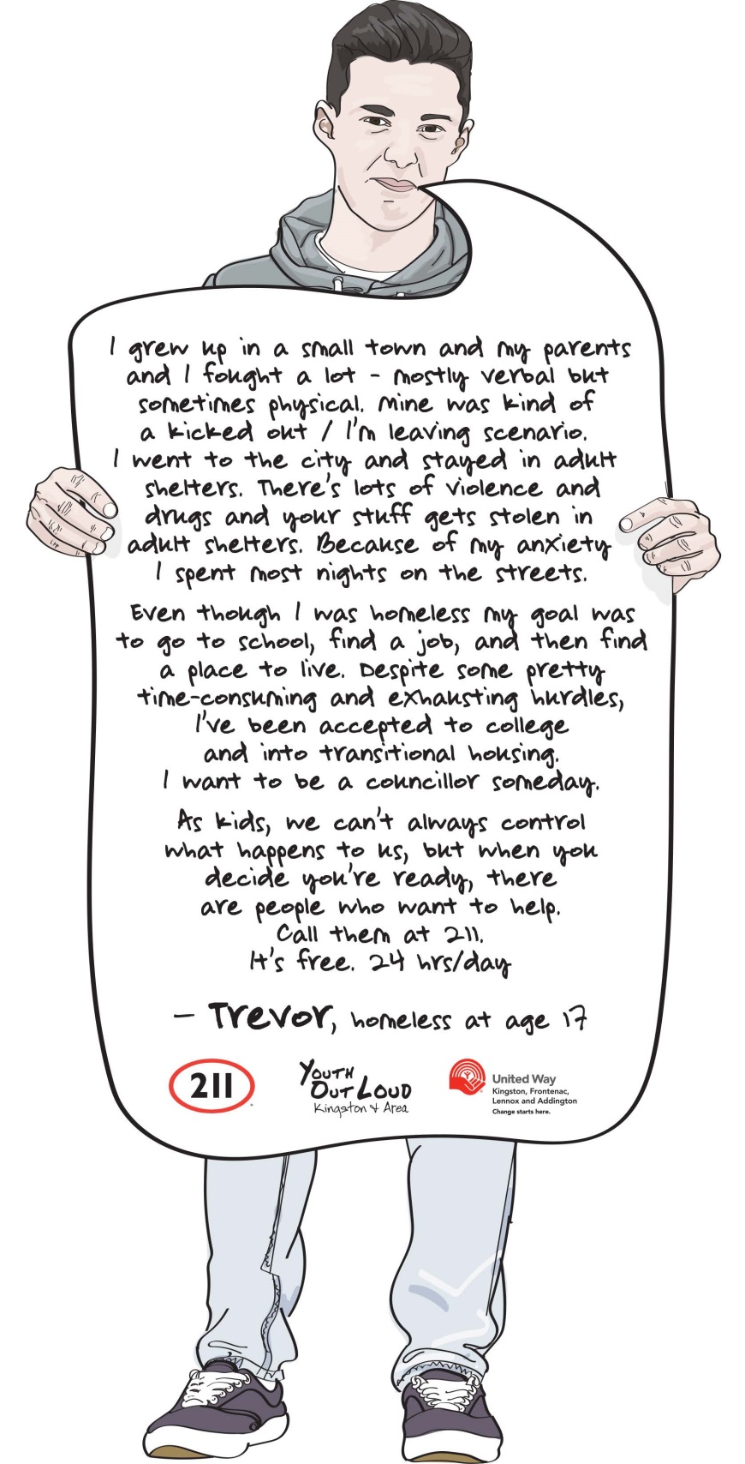
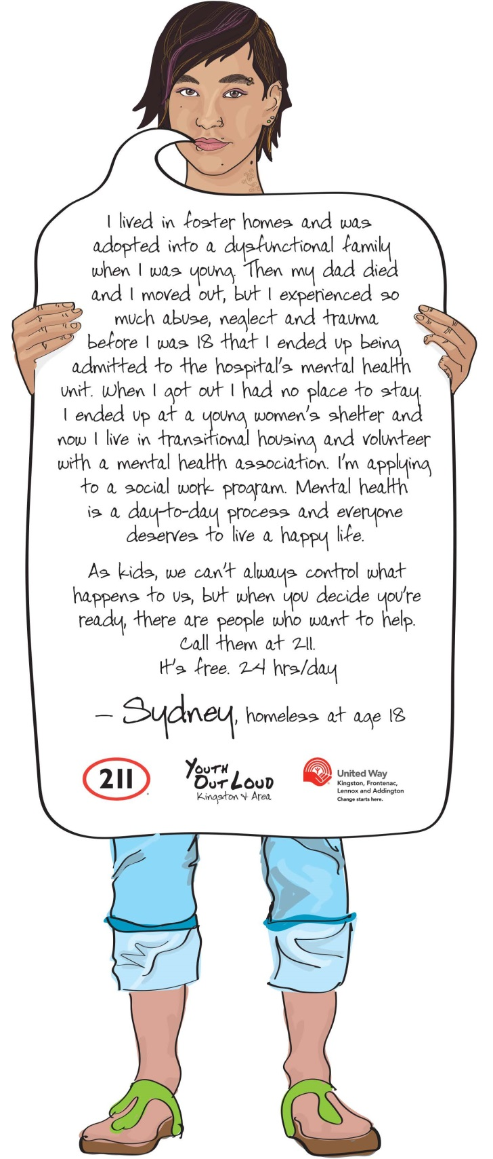
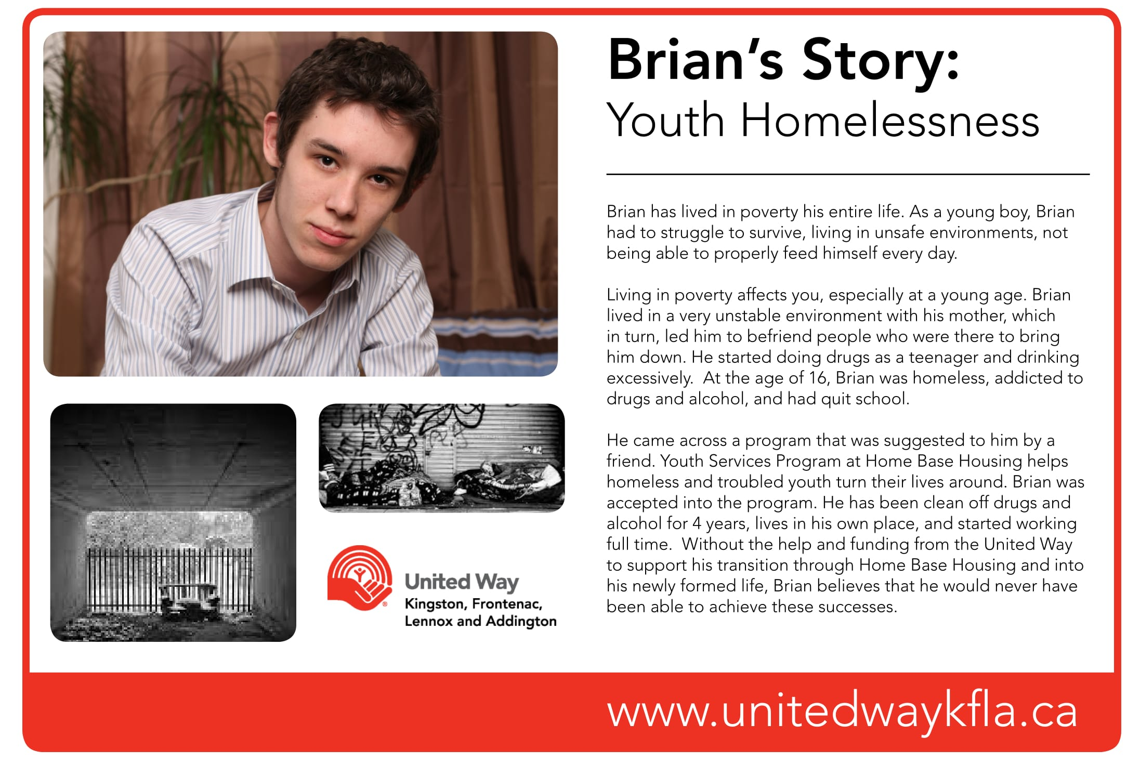
Impact Stories

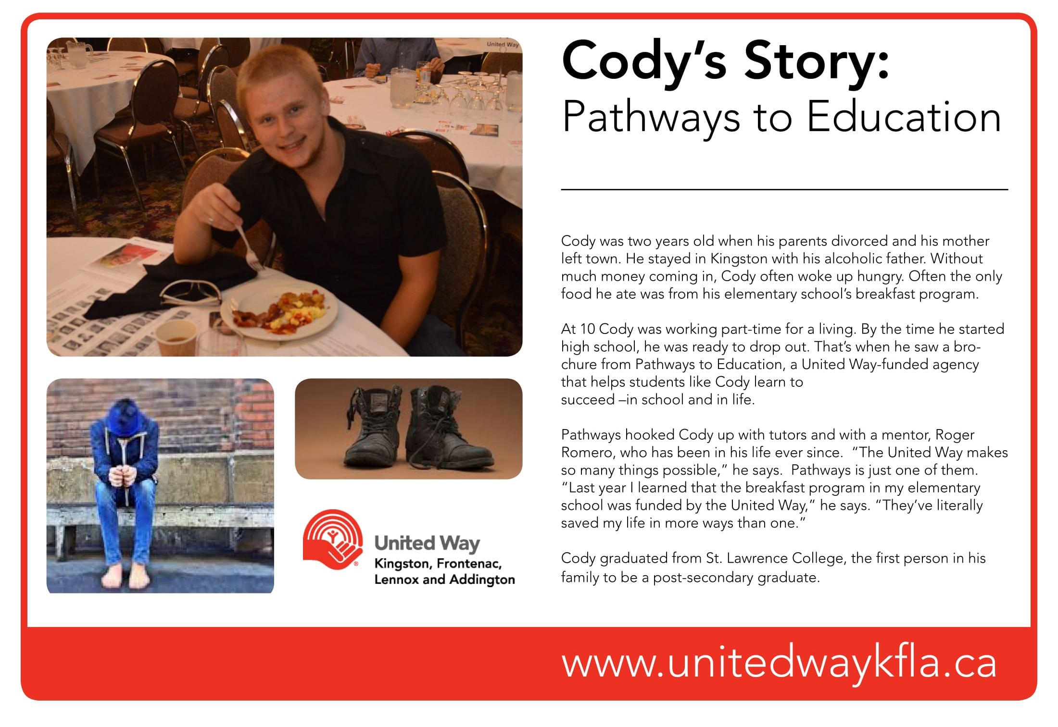
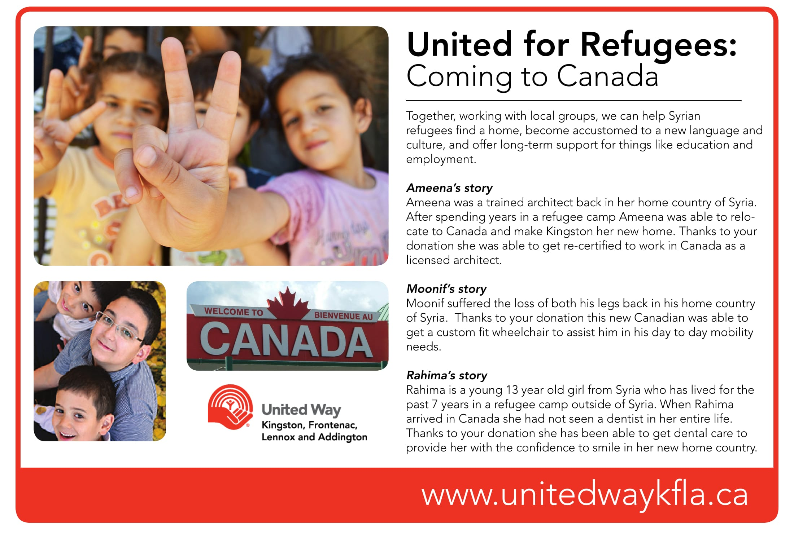
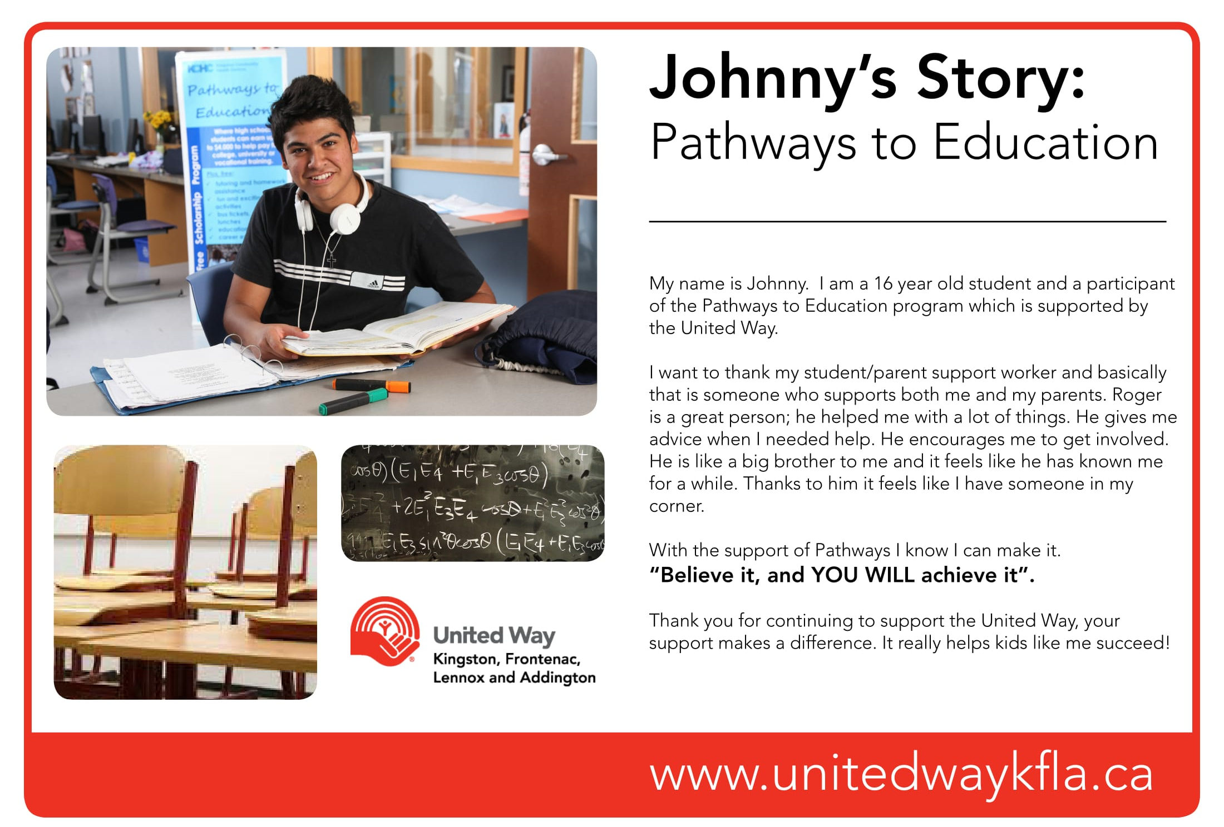
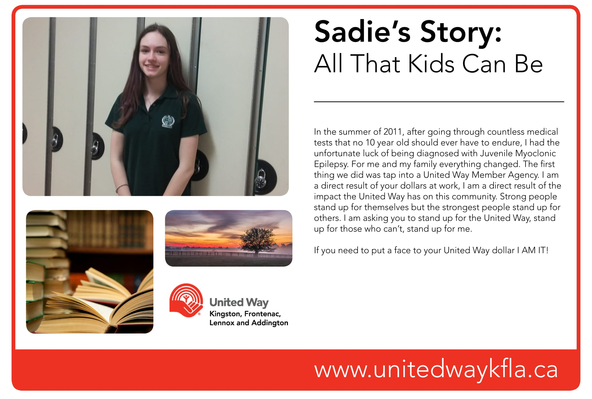
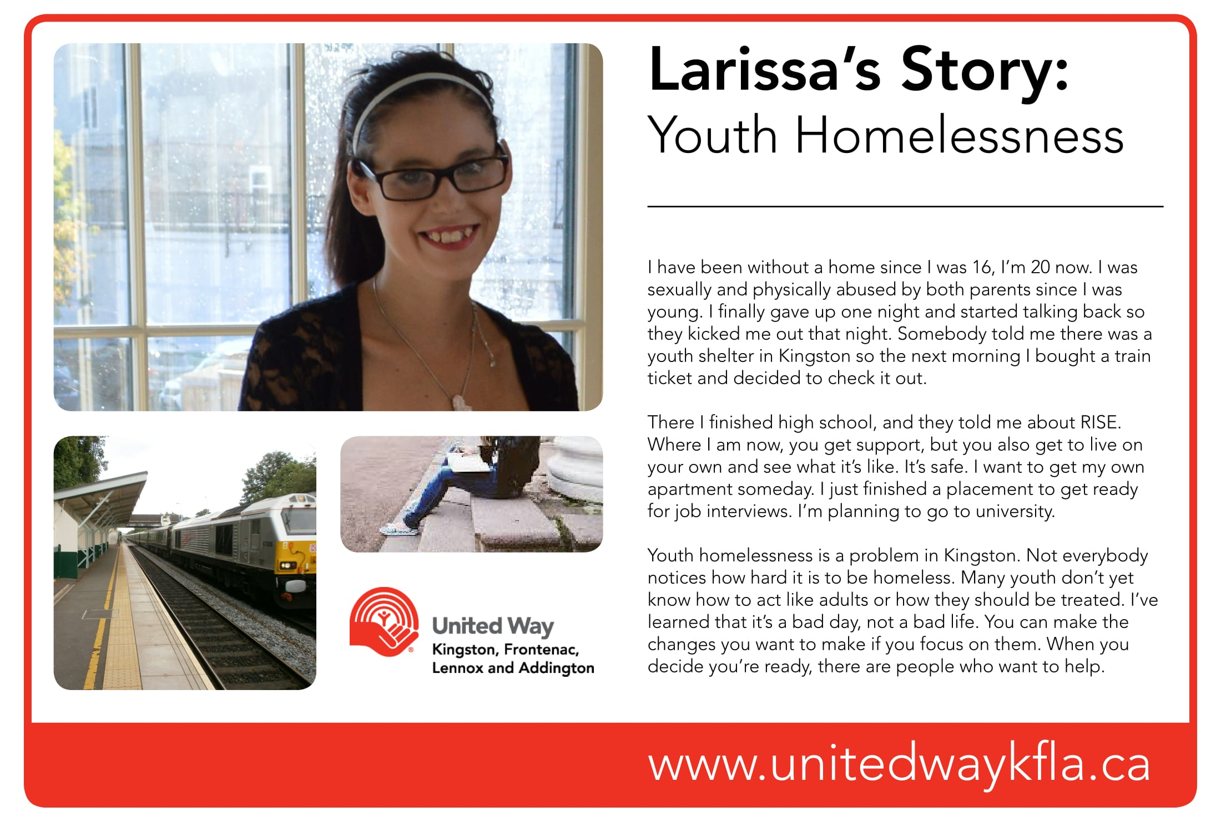
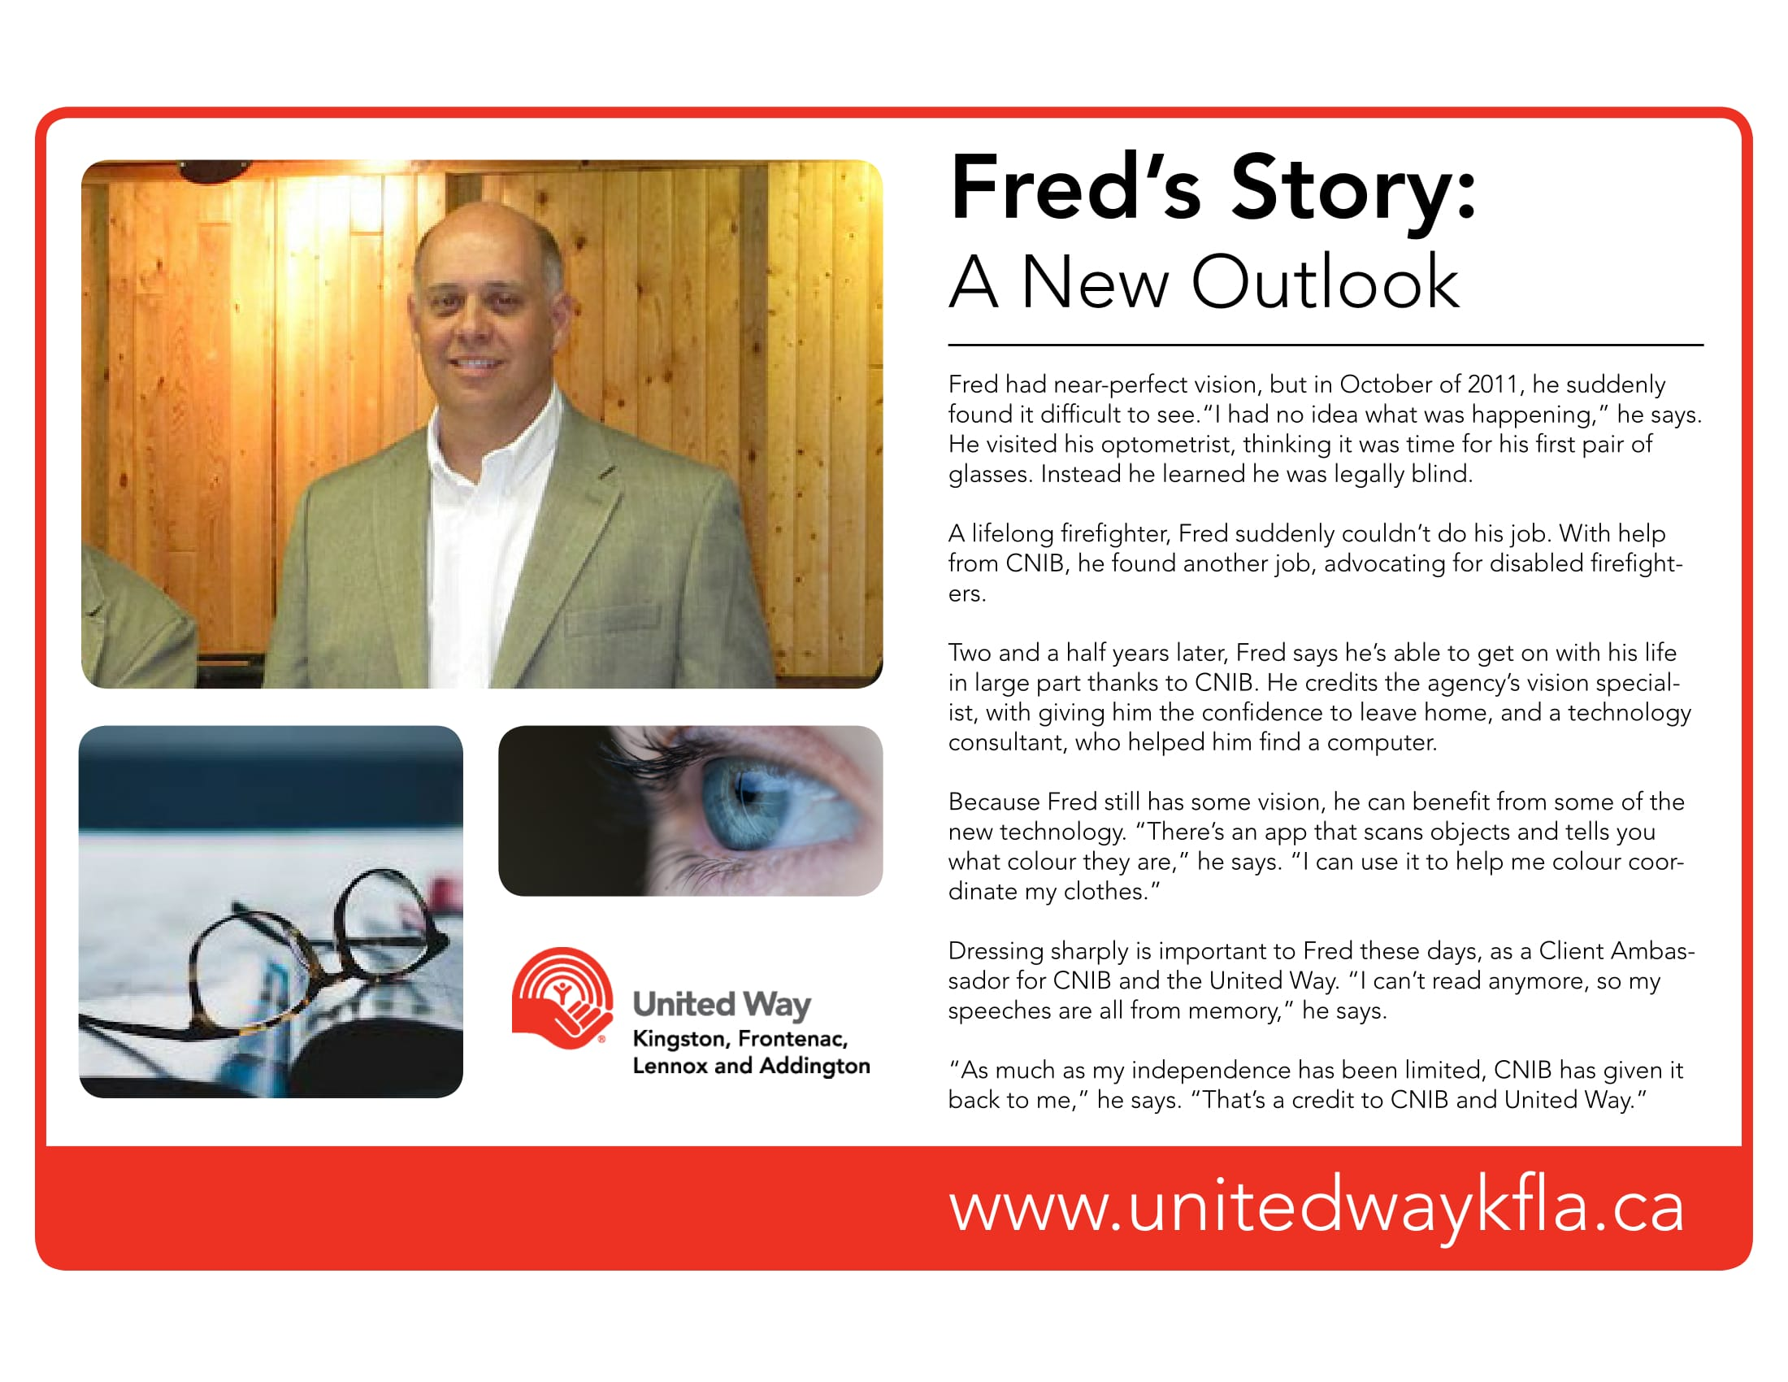
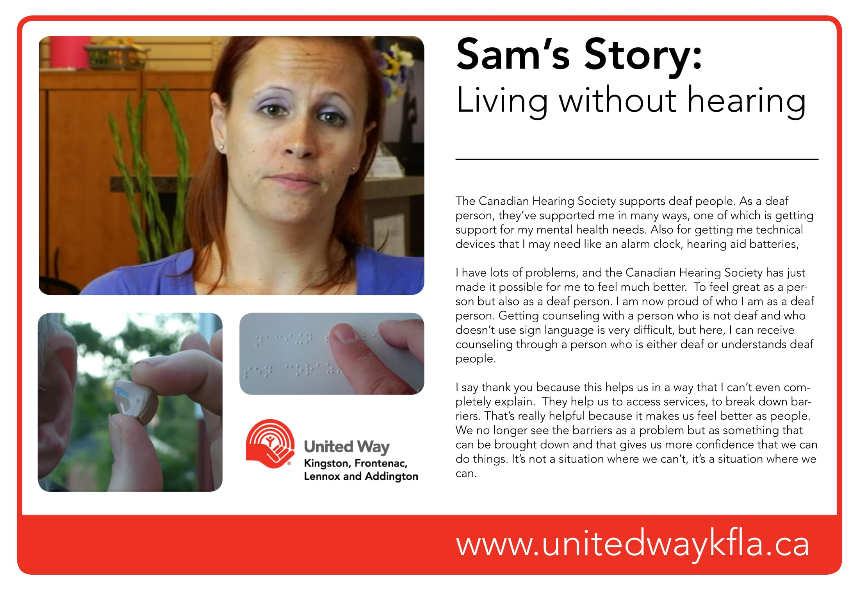
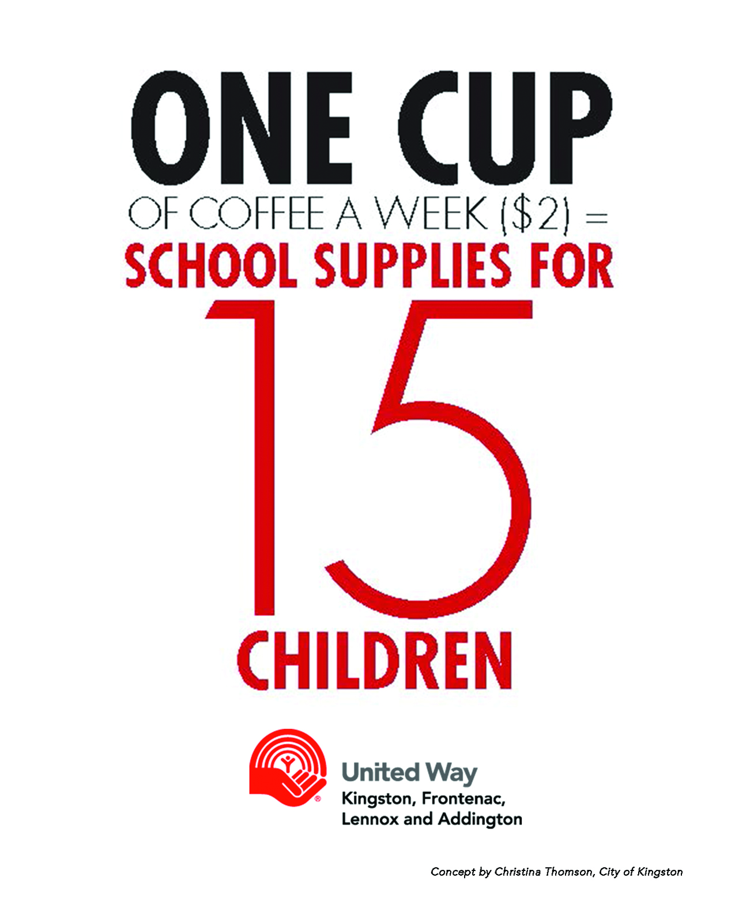
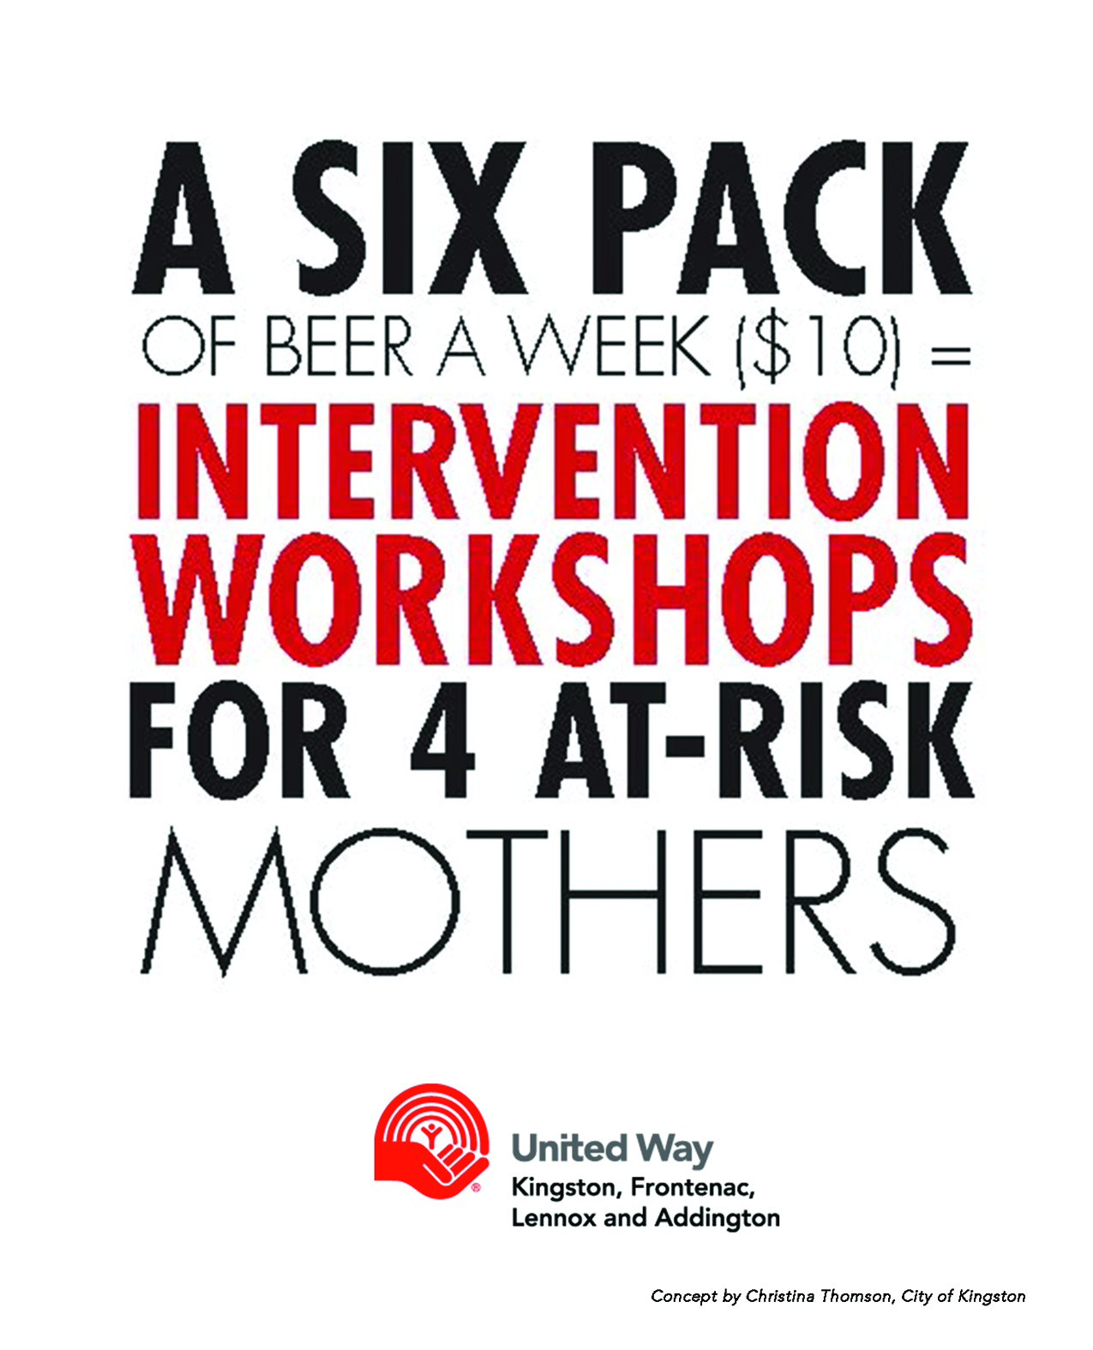
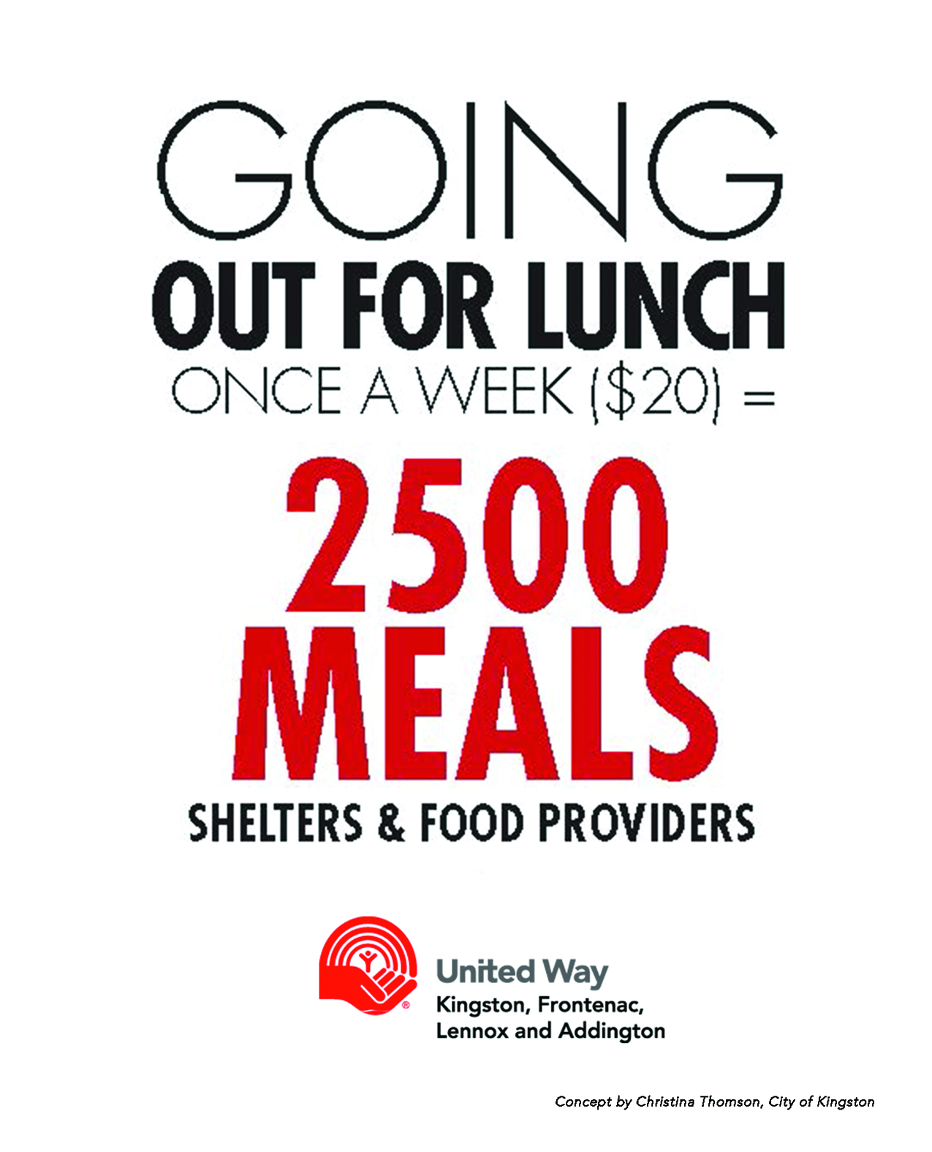
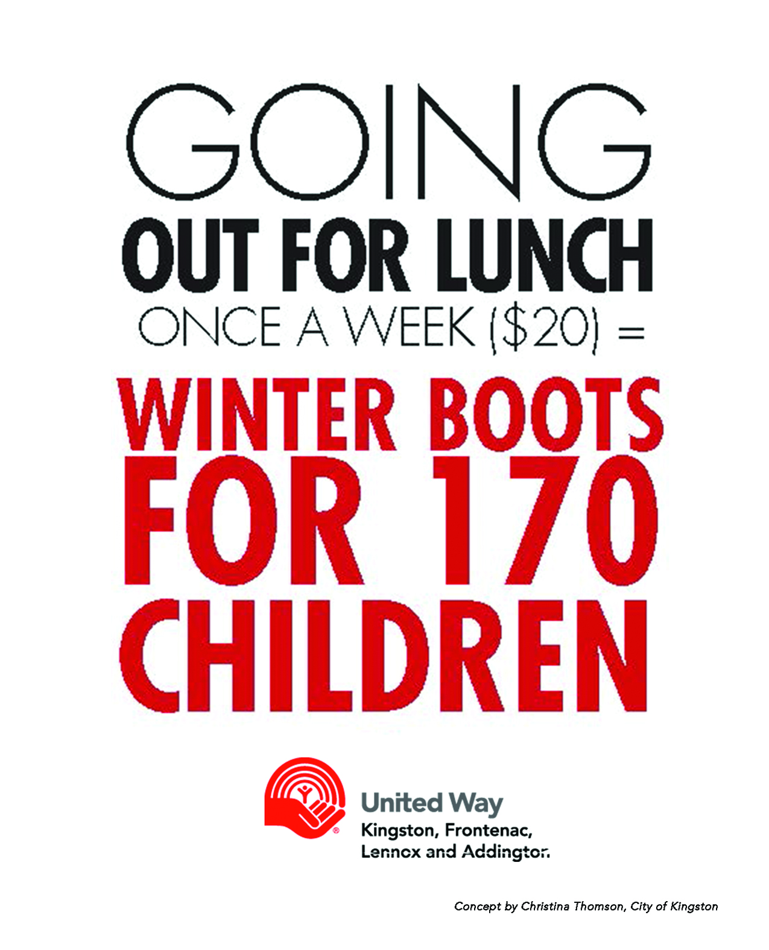
Value Insight
